Interface is a point of communication.

Interface 🡪 CUI(Command-line User Interface) and GUI (Graphical User Interface)

CUI

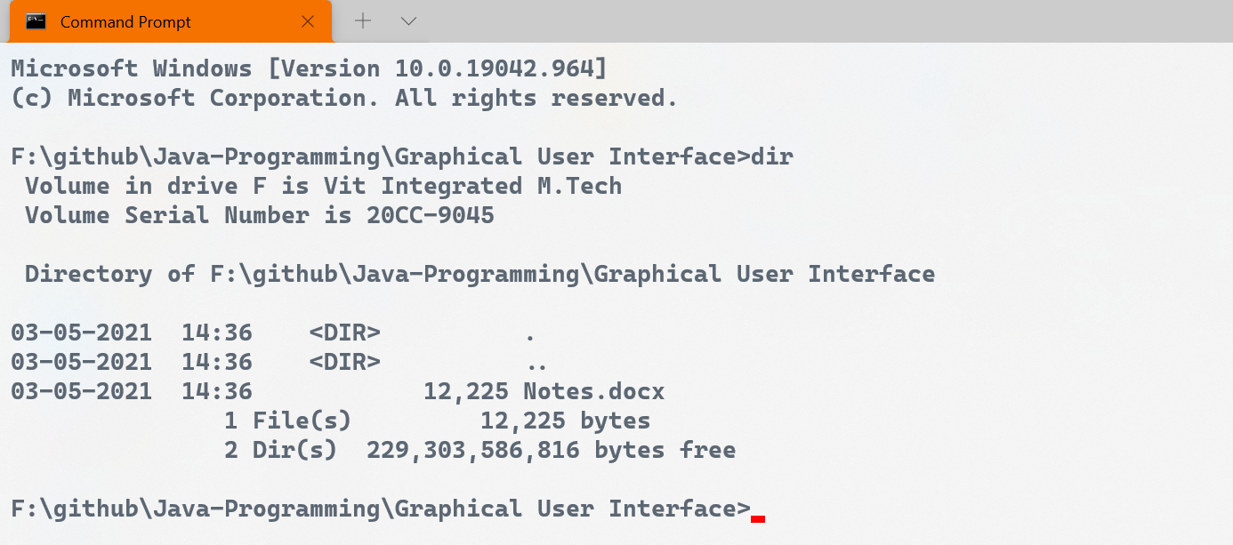

GUI

